

**UNIVERSIDAD TECNOLÓGICA DE**

**SAN LUIS RIO COLORADO**

**PORTFOLIO**

**MTRA. CINTHYA RIVERA DIAZ**

**ALUMNO: VICTOR MANUEL GALVAN COVARRUBIAS**

San Luis Rio Colorado, Sonora January, 2021

Exercise 1

1. Dennis made his sister do his homework.
2. Susan won the soccer championship cheating.
3. Robert watched the cartoons on the TV last night.
4. Harry lost his magic wand in the toilet.
5. Michael sent a package to his brother in Canada.

Exercise 2

1. Samuel brought a dog for his cousin.
2. Amanda ran away from the police in her car.
3. They are doing an exercise for the class.

Exercise 3

1. Lacy gave Fido and Spot some water.
2. Mother wrote my sister and me a note for school.
3. The bank loaned Mr. Dobbs and Ms. Garcia money for the store.
4. Calvin made the children a kite and a toy boat.
5. Jill passed Susan and Mike the potatoes.
6. The cowboy sang the herd a lullaby.
7. Kevin cook Lee and his sister soup and rice.

Exercise 4

1. He gave **her** the ring.
2. He sang **them** a song.
3. Give the **dog** a bone.

Exercise 5

1. She sent her friend an email. **IO**
2. Sally will help you with your homework. **DO**
3. Where did you put the keys? **S**
4. He gave them a bag full of money. **IO**
5. Alice wrote a book on the French revolution. **S**
6. I need your help. **DO**
7. He gave her a flower. **DO**
8. My father bought us a new TV. **IO**
9. John sold me his car. **DO**
10. I wish you good luck. **IO**

Exercise #6

1. Daniel has too much homework from his English teacher.
2. Susan bought the biggest cake of ice-cream.
3. Polo didn’t take his backpack in the morning.
4. She made her laptop explode with a virus.
5. They were not supposed to be on the living room.

Exercise #7

1. Shopping. 5
2. Pencil. 2
3. Exercise. 7
4. Orange. 4
5. Birthday. 8
6. Bedroom 10
7. Football. 9
8. Summer. 3
9. Mind. 1
10. Washing. 6
11. Book
12. Case
13. Holydays.
14. Juice.
15. List.
16. Machine.
17. Map.
18. Party.
19. Shoes.
20. Window.

**Exercise 8 Compound Nouns**

You need to construct compound nouns from these words in the box below to fill in the gaps in the sentences. Some of the words are used twice, but in a different order! All answers should be entered as two separate words.

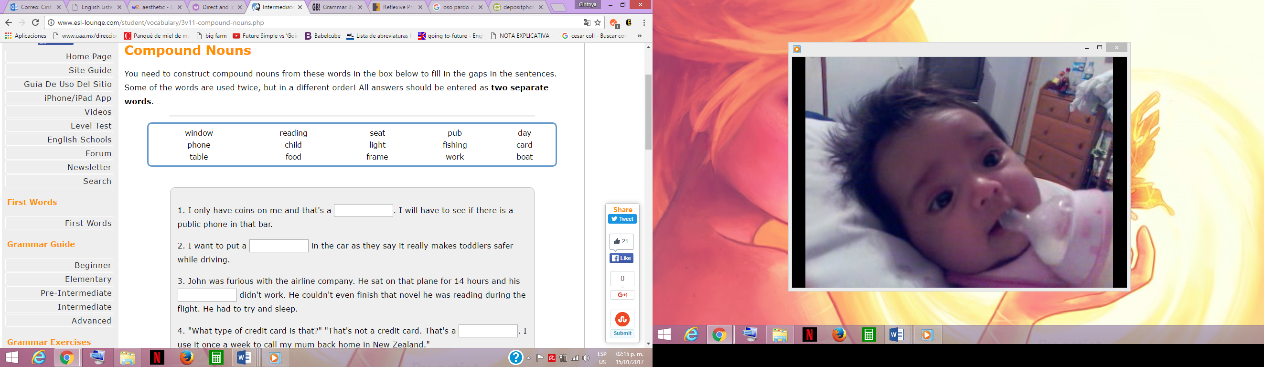

1. I only have coins on me and that's a **card phone**. I will have to see if there is a public phone in that bar.

2. I want to put a **child seat** in the car as they say it really makes toddlers safer while driving.

3. John was furious with the airline company. He sat on that plane for 14 hours and his **reading light** didn't work. He couldn't even finish that novel he was reading during the flight. He had to try and sleep.

4. "What type of credit card is that?" "That's not a credit card. That's a **phone card**. I use it once a week to call my mum back home in New Zealand."

5. All the **­­­­window frames** in this house have to be repainted. Otherwise, they will rot over the winter and then we may not be able to open the windows in the spring.

6. English restaurants have a terrible reputation, but the **pub food** is very tasty.

7. I worked at night for so long that when I finally started to do some **day work**, I found it really strange.

8. A **fishing boat** sank off the Spanish coast last night. Both fishermen were saved by the coast guard.

9. I know that Monday is a holiday for everyone else, but for us it's a **normal work day**. We have to get this project finished by Wednesday!

10. Why do you have a **pub table** in the middle of your lounge? I keep feeling tempted to go up to the bar to order drinks!!

Exercise 9

1. They were feeling very sorry themselves. Incorrect
2. She still dresses herself even do she’s 93. Correct
3. Behave yourself, Martin, the press is here tonight. Correct
4. I like to keep a few photographs with myself to remind myself of the old days. Incorrect
5. My son walked to school all by himself today. Correct
6. She quickly washed herself and dressed herself as she was already late for work. Incorrect
7. Although he kept a large collection of whiskies he rarely drank himself. Correct
8. There was a large number of stars present. The director by himself was also there. Incorrect

Correct

Incorrect

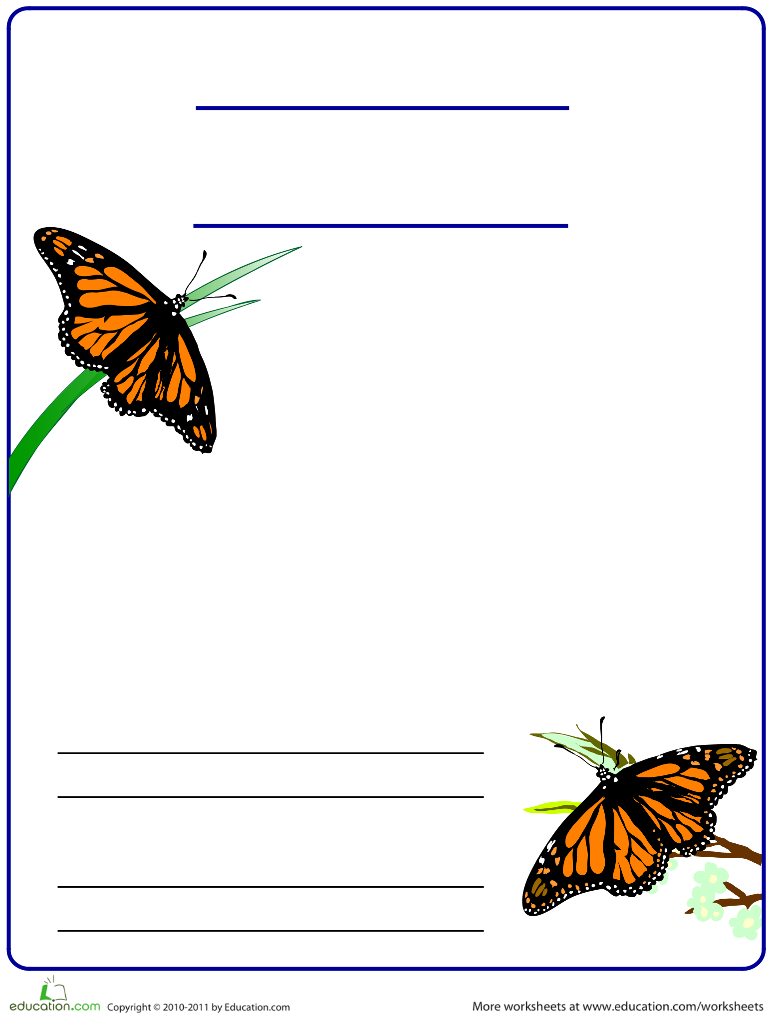Reading

**Find the Main Idea**

Exercise 10

**Find the main idea in the paragraph below. Write the main idea in your own words in the space provided. Then, write a concluding sentence for this paragraph.**

Viceroy

You know that butterflies are insects that glide through the air on colorful wings. Did you know they are also masters of disguise? For example, the Viceroy butterfly has evolved to look almost exactly like the monarch, a poisonous butterfly that predators know to avoid. Though the

Viceroy itself is not poisonous, birds and other predators steer clear, mistaking it for the Monarch. The Buckeye sports “eyespots”, target-shaped spots resembling eyes, on the tips of its wings. Predators will aim for an eyespot, believing it to be the head of the Buckeye, but will instead end up with just a wing tip, allowing the Buckeye to escape.

**Main idea:**

The viceroy butterfly.

**Concluding sentence:**

Next time you see a butterfly try to see if it is a viceroy or monarch.

Monarch